**I N D E X**

|  |  |  |  |  |  |
| --- | --- | --- | --- | --- | --- |
| Sr.  No. | Topic | Page No. | Date of Experiment | Date of Submission | Signature |
|  |  |  |  |  |  |
|  |  |  |  |  |  |
|  |  |  |  |  |  |
|  |  |  |  |  |  |
|  |  |  |  |  |  |
|  |  |  |  |  |  |
|  |  |  |  |  |  |
|  |  |  |  |  |  |
|  |  |  |  |  |  |
|  |  |  |  |  |  |
|  |  |  |  |  |  |
|  |  |  |  |  |  |
|  |  |  |  |  |  |
|  |  |  |  |  |  |
|  |  |  |  |  |  |
|  |  |  |  |  |  |
|  |  |  |  |  |  |
|  |  |  |  |  |  |
|  |  |  |  |  |  |
|  |  |  |  |  |  |
|  |  |  |  |  |  |
|  |  |  |  |  |  |
|  |  |  |  |  |  |

**Program 1**

**Objective : WAP in Java to print Hello.**

package Cos;

public class Q1printHello {

    public static void main(String[] args) {

        System.out.println("Hello World");

    }

}

**Output**

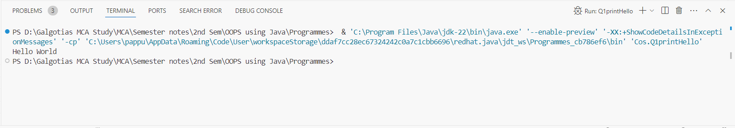

**Program 2**

**Objective : WAP in java to understand the difference between print() and println().**

package Cos;

public class Q2diffBetweenPrintPrintln {

    public static void main(String[] args) {

        System.out.print("Hello "); //This will print hello world followed by a new line

        System.out.println("world!");  // This will print "Hello from the println" followed by a newline

        // Printing multiple values using print()

        System.out.print("Java");

        System.out.print(" is");

        System.out.print(" awesome!");

        // This will print "Java is awesome!" without any newline

        // Printing multiple values using println()

        System.out.println("Java");

        System.out.println(" is");

        System.out.println(" awesome!");

        // This will print each word on a new line

    }

}

**Output**

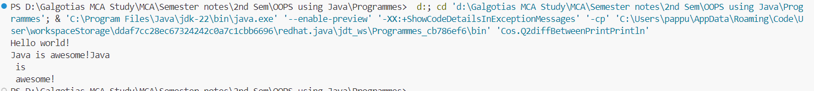

**Program 3**

**Objective : WAP in Java with two classes create a object of first class and call into another class (having main method).**

class first{

    public void display(){

        System.out.println("Hello from class first");

    }

}

class second extends first{

    public void display2(){

        System.out.println("Hello from class second");

    }

}

public class Q3TwoClass {

    public static void main(String[] args) {

        second s = new second();

        s.display();

        s.display2();

    }

}

**Output**

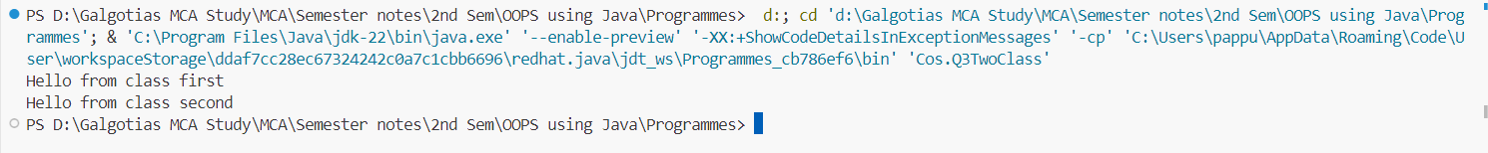

**Program 4**

**Objective : WAP in Java to product of two numbers.**

package Cos;

public class Q4Product {

    public static void main(String[] args) {

        int product = 5 * 6 ;

        System.out.println("The product is: " + product);

    }

}

**Output**



**Program 5**

**Objective : WAP in Java to product of two numbers (Input by the user).**

package Cos;

import java.util.Scanner;

public class Q5productByUser {

    public static void main(String[] args) {

        try (Scanner sc = new Scanner(System.in)) {

            System.out.println("Enter first number: ");

            int num1 = sc.nextInt();

            System.out.println("Enter second number: ");

            int num2 = sc.nextInt();

            int product = num1 * num2 ;

            System.out.println("The product is: " + product);

        }

    }

}

**Output**

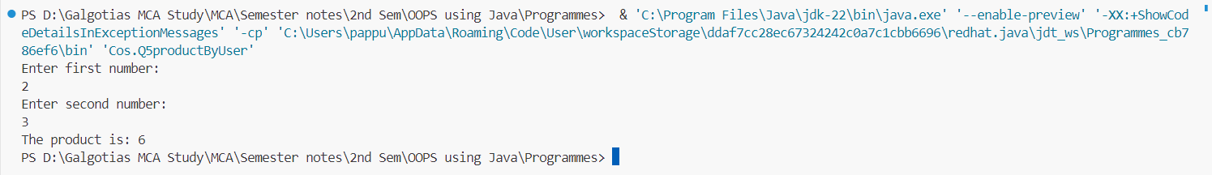

**Program 6**

**Objective : WAP in Java illustrate the concept of local instance and static variable.**

public class Q6 {

    // Static variable

    static int staticVar = 50;

    // Instance variable

    int instanceVar = 10;

    public static void main(String[] args) {

        // Local variable

        int localVar = 5;

        System.out.println("Static variable: " + staticVar);

        // Creating an object of the class to access instance variable

        Q6 obj = new Q6();

        System.out.println("Instance variable: " + obj.instanceVar);

        System.out.println("Local variable: " + localVar);

        // Calling a method to demonstrate usage of local, instance, and static variables

        obj.methodExample();

    }

    void methodExample() {

        // Accessing local, instance, and static variables within a method

        int localVar = 20;

        System.out.println("Inside method - Local variable: " + localVar);

        System.out.println("Inside method - Instance variable: " + instanceVar);

        System.out.println("Inside method - Static variable: " + staticVar);

    }

}

**Output**

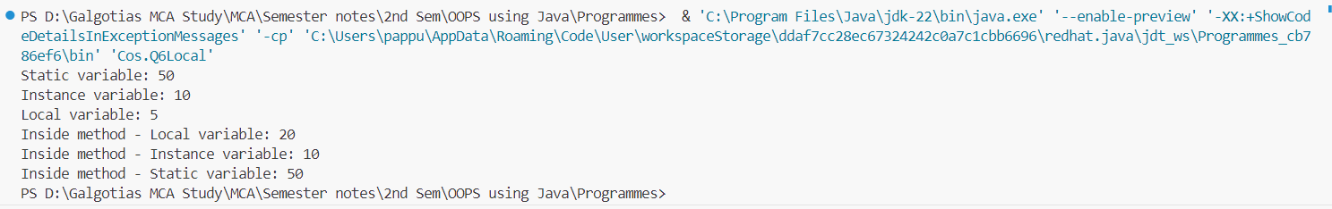

**Program 7**

**Object : WAP in Java to implement implicit and explicit type casting.**

package Cos;

public class Q7ImplecitandExplicit {

    public static void main(String [] args){

        int num = 90;

        double num2 = num; //Implicit type casting

        System.out.println("Implicit type casting Integer "+num+" to double  "+num2);

        double num3 = 45.00;

        int num4 = (int) num3; //Explicit type casting

        System.out.println("Explicit type casting Integer "+num3+" to double  "+num4);

    }

}

**Output**

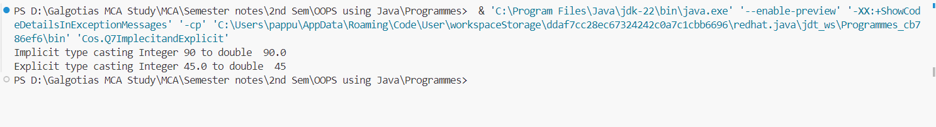

**Program 8**

Object : WAP in Java to implement the various operators in java.

package Cos;

public class Q8Operators {

    public static void main(String[] args){

        // Arithmetic Operators

        System.out.println("""

                           In Java Arithmetic operators:

                           1. Addition '+' : a + b or 5 + 6 = 11

                           2. Subtraction '-' : a - b or 9 - 8 = 1

                           3. Multiplication '*' : a * b or 7 * 4 = 28

                           4. Division '/' : a / b or 4 / 2 = 2

                           5. Modulus '%' : a % b or 5 % 2 = 1""");

        // Assignment Operators

        System.out.println("""

                           In Java Assignment Operators:

                           1. Assignment '=' : Assigns the value of the right operand to the left operand""");

        // Conditional Operators

        System.out.println("""

                           In Java Conditional Operators:

                           1. Ternary Operator '?:' : Evaluates a condition and returns one of two values

                           """);

        // Increment and Decrement Operators

        System.out.println("""

                           In Java Increment and Decrement Operators:

                           1. Increment '++' : Increases the value of a variable by 1

                           2. Decrement '--' : Decreases the value of a variable by 1

                           """);

        // Relational Operators

        System.out.println("""

                           In Java Relational Operators:

                           1. Greater than '>'

                           2. Greater than or equal to '>='

                           3. Less than '<'

                           4. Less than or equal to '<='

                           5. Equal to '=='

                           6. Not equal to '!='

                           """);

        // Logical Operators

        System.out.println("""

                           In Java Logical Operators:

                           1. Logical AND '&&'

                           2. Logical OR '||'

                           3. Logical NOT '!'""");

        // Bitwise Operators

        System.out.println("""

                           In Java Bitwise Operators:

                           1. Bitwise AND '&'

                           2. Bitwise OR '|'

                           3. Bitwise XOR '^'

                           4. Bitwise Complement '~'

                           5. Left Shift '<<'

                           6. Right Shift '>>'

                           7. Unsigned Right Shift '>>>'

                           """);

        // Unary Operators

        System.out.println("""

                           In Java Unary Operators:

                           1. Unary Plus '+'

                           2. Unary Minus '-'

                           3. Unary Increment '++'

                           4. Unary Decrement '--'

                           5. Logical NOT '!'

                           6. Bitwise Complement '~'""");

    }

}

**Output**

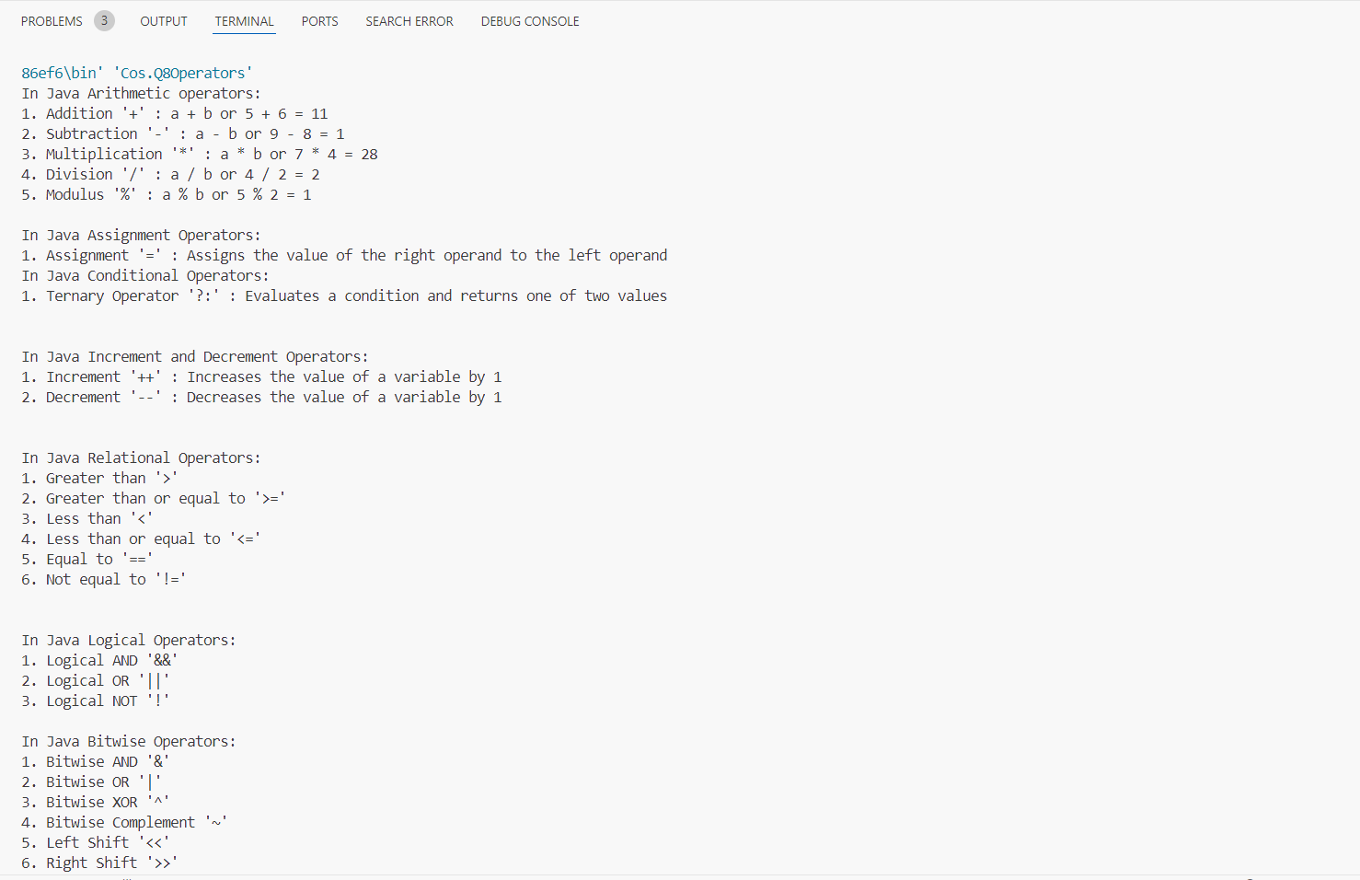

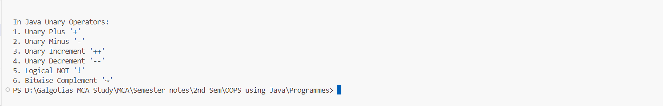

**Program 9**

**Objective: WAP in java for constructor overloading.**

package Cos;

public class Q9ConsOverload {

    int data = 50;

    // constructor overload

    public Q9ConsOverload() {

        this.data = 50;

    }

    public Q9ConsOverload(int data2) {

        this.data = data2;

    }

    public Q9ConsOverload(int data1,int data2) {

        this.data = data1 + data2;

    }

    public static void main(String[] args) {

        Q9ConsOverload obj1 = new Q9ConsOverload(10);

        Q9ConsOverload obj2 = new Q9ConsOverload(10, 20);

        Q9ConsOverload obj3 = new Q9ConsOverload();

    System.out.println("Constructor no parameters = " + obj1.data);

        System.out.println("Constructor with single parameters = " + obj2.data);

        System.out.println("Constructor with multiple parameters = " + obj3.data);

    }

}

**Output**

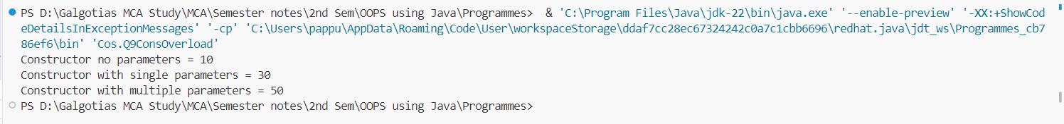

**Program 10**

Objective: WAP in java for method overloading.

package Cos;

public class Q10MethodOverloading {

    int add(){

        int a = 10;

        int b = 20;

        return a + b;

    }

    int add(int a, int b) {

        return a + b;

    }

    int add(int a, int b, int c) {

        return a + b + c;

    }

    public static void main(String []args){

        Q10MethodOverloading obj1 = new Q10MethodOverloading();

        Q10MethodOverloading obj2 = new Q10MethodOverloading();

        Q10MethodOverloading obj3 = new Q10MethodOverloading();

        System.out.println("Method with no parameter : "+obj1.add());

        System.out.println("Method with two parameter : "+obj2.add(10, 20));

        System.out.println("Method with three parameter : "+obj3.add(12,45,67));

    }

}

**Output**

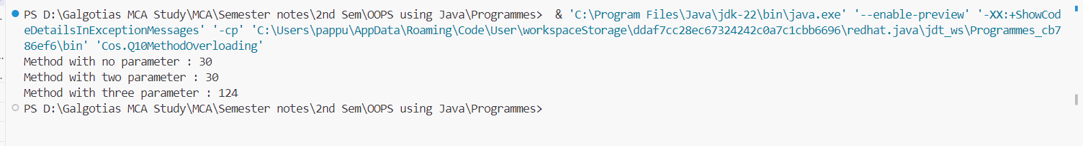

**Program 11**

**Objective : WAP in java for method overriding.**

package Cos;

class Man{

    void run(){

        System.out.println("Man Runninng");

    }

}

class Boy extends Man{

    @Override

    void run(){

        System.out.println("Boy Running");

    }

}

class Q11MethodOverriding{

    public static void main(String[] args) {

        Man man = new Man();

        man.run();

        Boy boy = new Boy();

        boy.run();

    }

}

  
**Output**

**Program 12**

**Objective: WAP in java to show run time polymorphism (up casting).**

package Cos;

public class Q12Polymorphism {

    static int add(int a, int b){

        return a + b;

    }

    static double add(double a,double b){

        return a + b;

    }

    public static void main(String []args){

        System.out.println("Addition of two integers : "+ add(14,15));

        System.out.println("Addition of two doubles : "+ add(18.5,17.5));

    }

}

**Output**

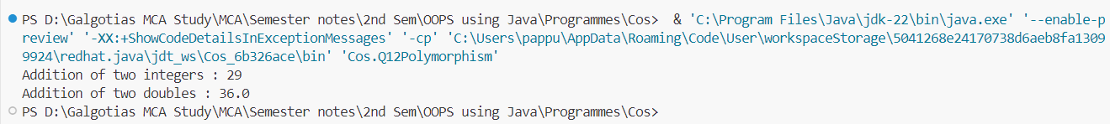

**Program 13**

**Objective: WAP in java for access specifiers (all four).**

package Cos;

public class Q13AccessSpecifier {

    public static int publicField = 10;

    private final static int privateField = 20;

    static int defaultField = 30;

    protected final static int protectedField = 40;

    public static void publicMethod() {

        System.out.println("This is a public method");

        System.out.println("Value of public int: " + publicField);

    }

    private static void privateMethod() {

        System.out.println("This is a private method");

        System.out.println("Value of private int: " + privateField);

    }

    static void defaultMethod() {

        System.out.println("This is a default method");

        System.out.println("Value of default int: " + defaultField);

    }

    protected static void protectedMethod() {

        System.out.println("This is a protected method");

        System.out.println("Value of protected int: " + protectedField);

    }

    public static void main(String[] args) {

        publicMethod();

        privateMethod();

        defaultMethod();

        protectedMethod();

    }

}

**Output**

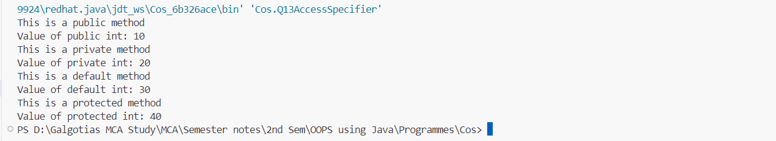

**Program 14**

**Objective: WAP in java to implement the single dimension array.**

package Cos;

import java.util.Scanner;

public class Q14SingleDimArray {

    public static void main(String[] args) {

        try (Scanner sc = new Scanner(System.in)) {

            int[] arr = new int[5];

            for(int i = 0; i < 5; i++){

                arr[i] = sc.nextInt();

            }

            for(int i = 0; i < 5; i++){

                System.out.println("Value in array index "+ i + " is "+ arr[i]);

            }

        }

    }

}

**Output**

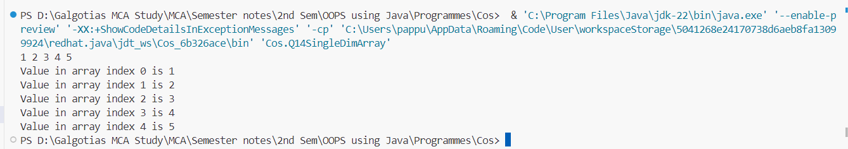

**Program 15**

**Objective: WAP in java to copy the elements from one array to another array.**

package Cos;

import java.util.Scanner;

public class Q15ArrayCopy {

    public static void main(String[] args) {

        try (Scanner sc = new Scanner(System.in)) {

            int[] arr1 = new int[5];

            int[] arr2 = new int[5];

            for(int i = 0; i < 5; i++){

                arr1[i] = sc.nextInt();

            }

            System.arraycopy(arr1, 0, arr2, 0, 5);

            for(int i = 0; i < 5; i++){

                System.out.println("Value in array index "+ i + " is "+ arr2[i]);

            }

        }

    }

}

Output

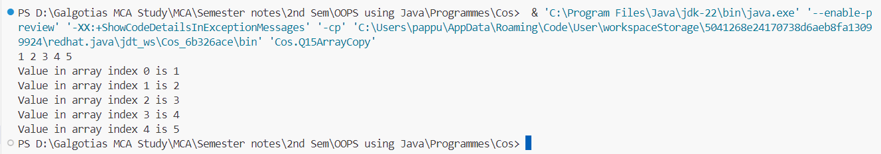

**Program 16**

**Objective: WAP in java to perform the addition and multiplication in 2-D array.**

package Cos;

import java.util.Scanner;

public class Q16AddMulin2D {

    public static void addMatrix(int[][] arr1, int[][] arr2, int[][] arr3) {

        int m = arr1.length;

        int n = arr1[0].length;

        for (int i = 0; i < m; i++) {

            for (int j = 0; j < n; j++) {

                arr3[i][j] = arr1[i][j] + arr2[i][j];

            }

        }

        System.out.println("Resultant matrix after addition:");

        printMatrix(arr3);

    }

    public static void multiplyMatrix(int[][] arr1, int[][] arr2, int[][] arr3) {

        int m = arr1.length;

        int n = arr1[0].length;

        int p = arr2[0].length;

        for (int i = 0; i < m; i++) {

            for (int j = 0; j < p; j++) {

                arr3[i][j] = 0; // Reset value before calculating

                for (int k = 0; k < n; k++) {

                    arr3[i][j] += arr1[i][k] * arr2[k][j];

                }

            }

        }

    }

    public static void inputMatrix(int[][] matrix, Scanner sc) {

        for (int i = 0; i < matrix.length; i++) {

            for (int j = 0; j < matrix[i].length; j++) {

                matrix[i][j] = sc.nextInt();

            }

        }

    }

    public static void printMatrix(int[][] matrix) {

        for (int i = 0; i < matrix.length; i++) {

            for (int j = 0; j < matrix[i].length; j++) {

                System.out.print(matrix[i][j] + " ");

            }

            System.out.println();

        }

    }

    public static void main(String[] args) {

        try (Scanner sc = new Scanner(System.in)) {

            System.out.println("Enter size of first matrix (m x n): ");

            int m = sc.nextInt();

            int n = sc.nextInt();

            System.out.println("Enter size of second matrix (o x p): ");

            int o = sc.nextInt();

            int p = sc.nextInt();

            if (n == o) {

                int[][] arr1 = new int[m][n];

                int[][] arr2 = new int[o][p];

                int[][] arr3 = new int[m][p];

                System.out.println("Enter elements of first matrix:");

                inputMatrix(arr1, sc);

  System.out.println("Enter elements of second matrix:");

                inputMatrix(arr2, sc);

                   // Perform addition

                addMatrix(arr1, arr2, arr3);

    // Perform multiplication

                System.out.println("Resultant matrix after multiplication:");

                multiplyMatrix(arr1, arr2, arr3);

            } else {

                System.out.println("Matrices are not compatible for multiplication. Exiting...");

            }

        }

    }

}

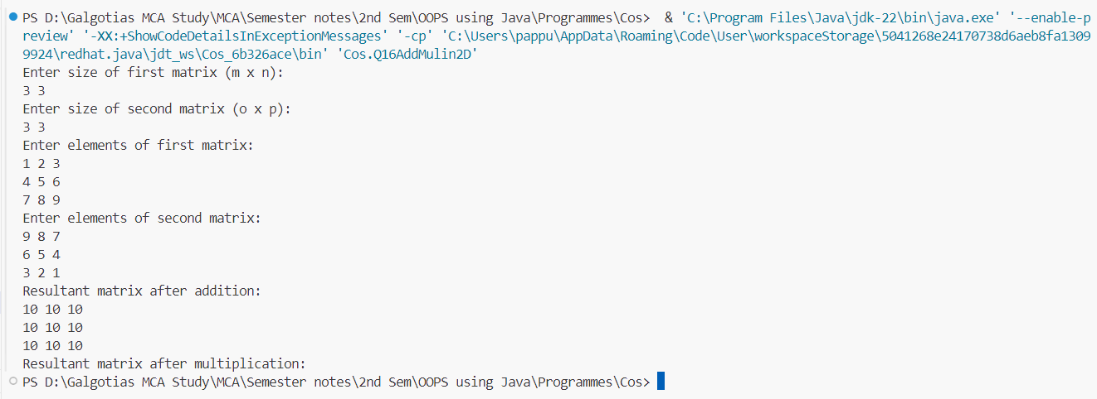**Output**

**Program 17**

**Objective: WAP in java for simple inheritance.**

package Cos;

// Parent class

class A {

    void display() {

        System.out.println("This is the parent class");

    }

}

// Single Inheritance

class B extends A {

    void show() {

        System.out.println("This is the child class");

    }

}

// Multilevel Inheritance

class C extends B {

    void greet() {

        System.out.println("Hello from the grandchild class");

    }

}

// Hierarchical Inheritance

class D extends C {

    void message() {

        System.out.println("This is another child class");

    }

}

// Main class

public class Q17Inhheritence {

    public static void main(String[] args) {

        // Single Inheritance

        B child = new B();

        child.display();

        child.show();

        System.out.println();

        // Multilevel Inheritance

        C grandChild = new C();

        grandChild.display();

        grandChild.show();

        grandChild.greet();

        System.out.println();

        // Hierarchical Inheritance

        D anotherChild = new D();

        anotherChild.display();

        anotherChild.message();

    }

}

**Output**

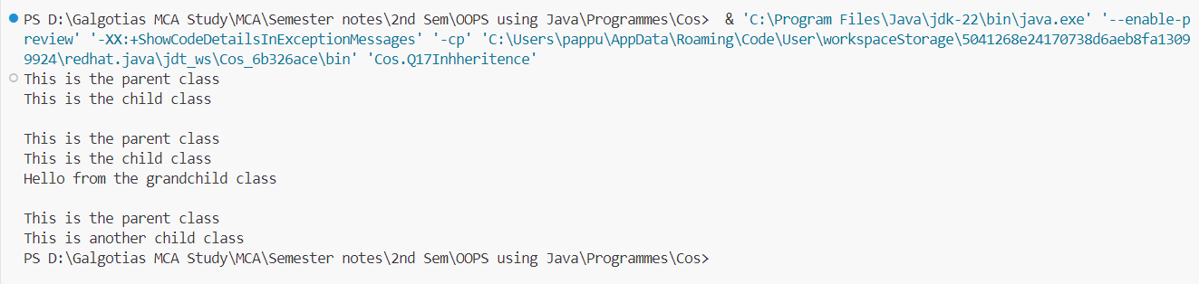

**Program 18**

**Objective: WAP in java for Final Keyword.**

//WAP in java for Final keyword

package Cos;

class Q18final {

    public static void main(String[] args) {

        final int x = 10;

        // x = 20; // Error: Cannot assign a value to final variable x

        System.out.println("Value of x: " + x);

    }

}

**Output**



**Program 19**

**Objective: WAP in java for Super Keyword.**

package Cos;

//WAP in java for super keyword

class Parent {

    Parent() {

        System.out.println("This is Parent class constructor.");

    }

}

class Child extends Parent {

    Child() {

        super(); // Calling Parent class constructor

        System.out.println("This is Child class constructor.");

    }

}

public class Q19Super {

    public static void main(String[] args) {

        Child childObj = new Child();

    }

}

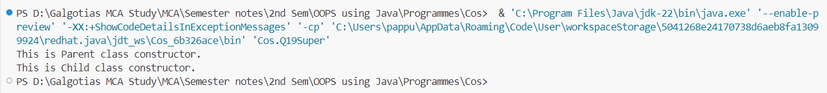

**Program 20**

**Objective: WAP in java for chaining constructor.**

package Cos;

//WAP in java for chaining constructor

public class Q20ConstructorChain {

    private String name;

    private int age;

    // Default constructor

    public Q20ConstructorChain() {

        this("Unknown", 0);  // Calling parameterized constructor

    }

    // Parameterized constructor

    public Q20ConstructorChain(String name, int age) {

        this.name = name;

        this.age = age;

    }

    public void display() {

        System.out.println("Name: " + name);

        System.out.println("Age: " + age);

    }

    public static void main(String[] args) {

        Q20ConstructorChain person1 = new Q20ConstructorChain();  // Calls default constructor

        Q20ConstructorChain person2 = new Q20ConstructorChain("John", 30);  // Calls parameterized constructor

        person1.display();

        person2.display();

    }

}

**Output**

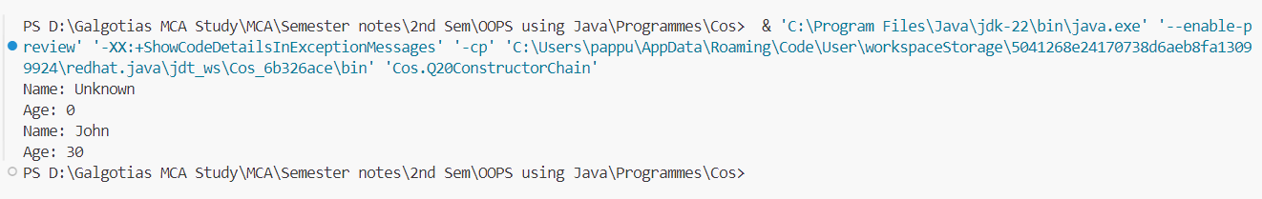

**Program 21**

**Objective: WAP in java for abstract method and abstract class.**

//WAP in java for abstract method and abstract class

package Cos;

// Abstract class

abstract class Shape {

    // Abstract method (no implementation)

    abstract void draw();

    // Concrete method

    void display() {

        System.out.println("Displaying shape...");

    }

}

// Concrete subclass of Shape

class Circle extends Shape {

    // Implementing abstract method

    void draw() {

        System.out.println("Drawing circle...");

    }

}

// Concrete subclass of Shape

class Rectangle extends Shape {

    // Implementing abstract method

    void draw() {

        System.out.println("Drawing rectangle...");

    }

}

public class Q21Abstract {

    public static void main(String[] args) {

        Shape shape1 = new Circle();  // Upcasting

        Shape shape2 = new Rectangle();  // Upcasting

        shape1.draw();

        shape1.display();

        shape2.draw();

        shape2.display();

    }

}

**Output**

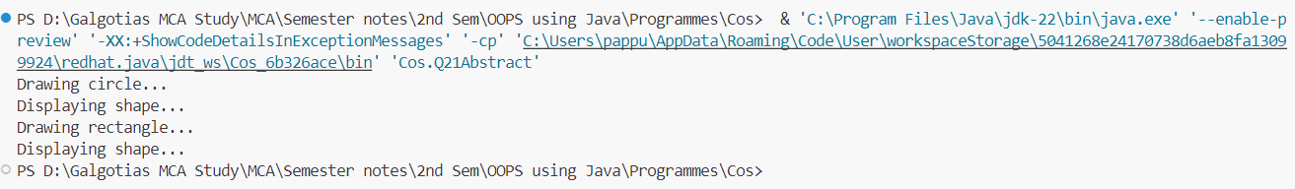

**Program 22**

**Objective: WAP in java for interface.**

//WAP in java for interface

package Cos;

// Define an interface

interface Animal {

    // Abstract method (does not have a body)

    void sound();

    // Default method

    default void eat() {

        System.out.println("This animal eats food.");

    }

    // Static method

    static void sleep() {

        System.out.println("This animal sleeps.");

    }

}

// Implementing the Animal interface

class Dog implements Animal {

    // Implementing sound method

    public void sound() {

        System.out.println("Dog barks");

    }

    // Overriding the default eat method

    public void eat() {

        System.out.println("Dog eats bones.");

    }

}

// Implementing the Animal interface

class Cat implements Animal {

    // Implementing sound method

    public void sound() {

        System.out.println("Cat meows");

    }

}

public class Q22Interface {

    public static void main(String[] args) {

        Animal myDog = new Dog();  // Upcasting

        Animal myCat = new Cat();  // Upcasting

        myDog.sound();

        myDog.eat();  // Overridden method

        Animal.sleep();  // Static method

        myCat.sound();

        myCat.eat();  // Default method

        Animal.sleep();  // Static method

    }

}

**Output**

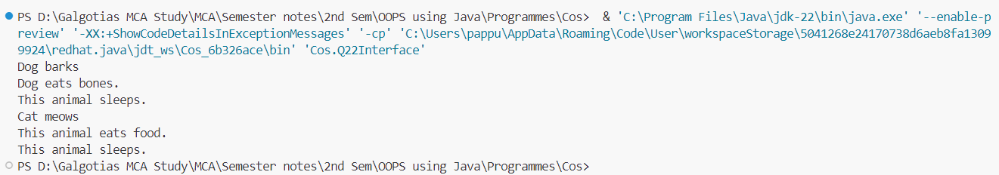

**Program 23**

**Objective: WAP in java for multiple inheritance.**

package Cos;

// Interface for Animal

interface Animal {

    void eat();

}

// Interface for Bird

interface Bird {

    void fly();

}

// Class implementing multiple interfaces

class Sparrow implements Animal, Bird {

    @Override

    public void eat() {

        System.out.println("Sparrow eats insects.");

    }

    @Override

    public void fly() {

        System.out.println("Sparrow flies high.");

    }

}

public class Q23InterfaceAnimal {

    public static void main(String[] args) {

        Sparrow sparrow = new Sparrow();

        // Calling methods

        sparrow.eat();

        sparrow.fly();

    }

}

**Output**

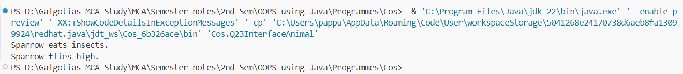

**Program 24**

**Objective: WAP in java for Object Cloning(shallow and deep copy).**

package Cos;

// Class to be cloned

class Student implements Cloneable {

    String name;

    Address address;

    public Student(String name, Address address) {

        this.name = name;

        this.address = address;

    }

    // Shallow copy

    protected Object clone() throws CloneNotSupportedException {

        return super.clone();

    }

    // Deep copy

    public Student deepClone() {

        Address clonedAddress = new Address(this.address.street, this.address.city);

        return new Student(this.name, clonedAddress);

    }

    @Override

    public String toString() {

        return "Student [name=" + name + ", address=" + address + "]";

    }

}

// Address class for deep copy

class Address {

    String street;

    String city;

    public Address(String street, String city) {

        this.street = street;

        this.city = city;

    }

    @Override

    public String toString() {

        return "Address [street=" + street + ", city=" + city + "]";

    }

}

public class Q24ClassClone {

    public static void main(String[] args) throws CloneNotSupportedException {

        Address address = new Address("123 Main St", "City");

        Student originalStudent = new Student("John", address);

        // Shallow copy

        Student clonedStudent = (Student) originalStudent.clone();

        System.out.println("Shallow Copy: ");

        System.out.println("Original: " + originalStudent);

        System.out.println("Cloned: " + clonedStudent);

        // Deep copy

        Student deepClonedStudent = originalStudent.deepClone();

        System.out.println("\nDeep Copy: ");

        System.out.println("Original: " + originalStudent);

        System.out.println("Deep Cloned: " + deepClonedStudent);

    }

}

**Output**

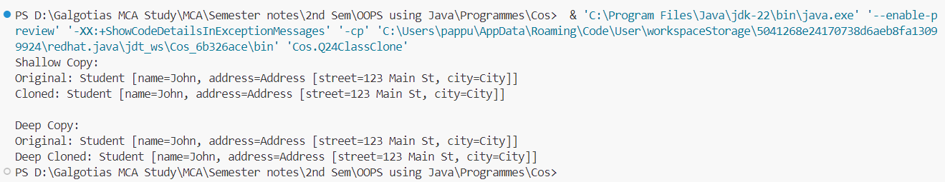

**Program 25**

**Objective: WAP in java for Inner Classes (all types).**

package Cos;

public class Q25NestedClass {

    // Nested Inner Class (Static Inner Class)

    static class StaticInnerClass {

        void display() {

            System.out.println("Inside Static Inner Class");

        }

    }

    // Non-static Nested Inner Class (Inner Class)

    class InnerClass {

        void display() {

            System.out.println("Inside Non-static Inner Class");

        }

    }

    // Method with Local Inner Class

    void localInnerClassExample() {

        class LocalInner {

            void display() {

                System.out.println("Inside Local Inner Class");

            }

        }

        LocalInner localInner = new LocalInner();

        localInner.display();

    }

    // Method with Anonymous Inner Class

    void anonymousInnerClassExample() {

        Thread t = new Thread(new Runnable() {

            @Override

            public void run() {

                System.out.println("Inside Anonymous Inner Class");

            }

        });

        t.start();

    }

    public static void main(String[] args) {

        // Accessing Static Inner Class

        Q25NestedClass.StaticInnerClass staticInnerObj = new Q25NestedClass.StaticInnerClass();

        staticInnerObj.display();

        // Accessing Non-static Inner Class

        Q25NestedClass outerObj = new Q25NestedClass();

        Q25NestedClass.InnerClass innerObj = outerObj.new InnerClass();

        innerObj.display();

        // Accessing Local Inner Class

        outerObj.localInnerClassExample();

        // Accessing Anonymous Inner Class

        outerObj.anonymousInnerClassExample();

    }

}

**Output**

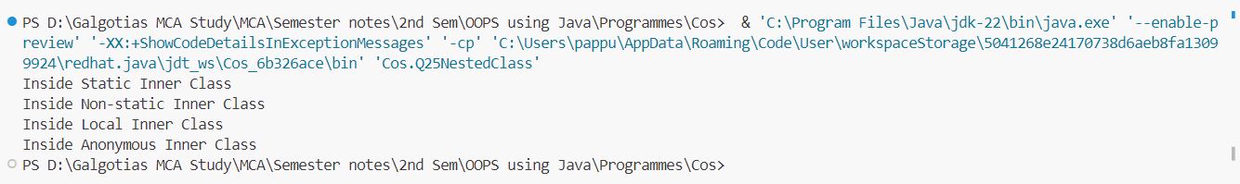

**Program 26**

**Objective: WAP in java to create the package (user defined package).**

File 1:

// Here Package same name as directory is created with class HelloWorld same name as file name

// This file is located in directory 'MyPackage'

// This directory is created where the jdk is located, inside the 'bin' directory

package Cos;

public class Q26PackageF1 {

    public void sayHello() {

        System.out.println("Hello, World!");

    }

}

**Output**



File 2:

// This file is located in bin directory

// Here package is imported

import Cos.HelloWorld;

public class Q26Package {

public static void main(String[] args) {

  HelloWorld hello = new HelloWorld();

        hello.sayHello();

  }

}

**Output**

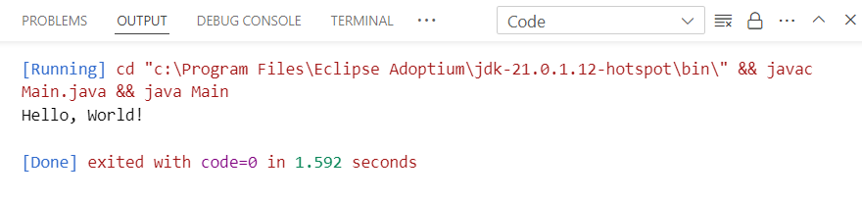

**Program 27**

**Objective: WAP in java for exception handling by using try, catch and finally.**

package Cos;

public class Q27TryCatch {

    public static void main(String[] args) {

        try {

            // Code that may throw an exception

            int result = divide(10, 0);

            System.out.println("Result: " + result);

        } catch (ArithmeticException e) {

            // Catching specific exception

            System.out.println("Exception caught: Division by zero");

        } finally {

            // Code that will always execute, regardless of whether an exception occurred or not

            System.out.println("Finally block executed");

        }

}

public static int divide(int dividend, int divisor) {

        return dividend / divisor;

    }

}

**Output**

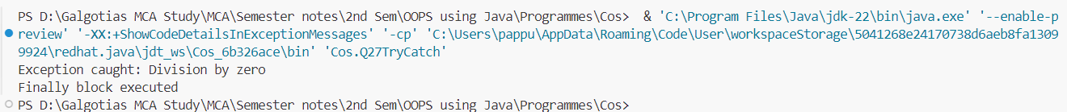

**Program 28**

**Objective: WAP in java for throw and throws Exception.**

package Cos;

public class Q27TryCatch {

    public static void main(String[] args) {

        try {

            // Code that may throw an exception

            int result = divide(10, 0);

            System.out.println("Result: " + result);

        } catch (ArithmeticException e) {

            // Catching specific exception

            System.out.println("Exception caught: Division by zero");

        } finally {

            // Code that will always execute, regardless of whether an exception occurred or not

            System.out.println("Finally block executed");

        }

    }

    public static int divide(int dividend, int divisor) {

        return dividend / divisor;

    }

}

**Output**

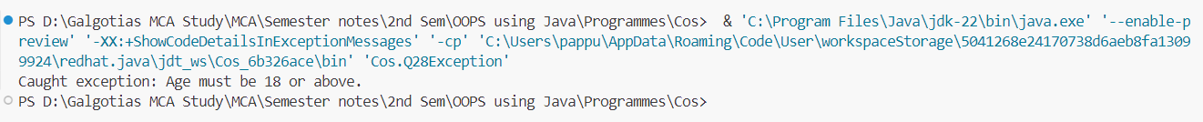

**Program 29**

**Objective: WAP in java to throw your own Exceptions.**

package Cos;

public class Q29CustomException {

    public static void main(String[] args) {

        try {

            // Simulating a condition where a custom exception needs to be thrown

            int balance = 100;

            int amountToWithdraw = 200;

            withdrawMoney(balance, amountToWithdraw);

        } catch (InsufficientBalanceException e) {

            System.out.println("Caught exception: " + e.getMessage());

        }

    }

    // Method that throws a custom exception if the balance is insufficient

    public static void withdrawMoney(int balance, int amount) throws InsufficientBalanceException {

        if (balance < amount) {

            throw new InsufficientBalanceException("Insufficient balance in the account.");

        } else {

            System.out.println("Withdrawal successful. Remaining balance: " + (balance - amount));

        }

    }

}

// Custom exception class for insufficient balance

class InsufficientBalanceException extends Exception {

    public InsufficientBalanceException(String message) {

        super(message);

    }

}

**Output**



**Program 30**

**Objective: WAP in java to reading and writing in file using byte stream.**

package Cos;

import java.io.FileInputStream;

import java.io.FileOutputStream;

import java.io.IOException;

public class Q30FileIO {

    public static void main(String[] args) {

        String fileName = "example.txt";

        String content = "Hello, this is a sample text.";

        // Writing to a file using FileOutputStream

        try (FileOutputStream outputStream = new FileOutputStream(fileName)) {

            byte[] bytes = content.getBytes();

            outputStream.write(bytes);

            System.out.println("Content written to file successfully.");

        } catch (IOException e) {

            System.out.println("Error writing to file: " + e.getMessage());

        }

        // Reading from a file using FileInputStream

        try (FileInputStream inputStream = new FileInputStream(fileName)) {

            int ch;

            System.out.println("Content read from file:");

            while ((ch = inputStream.read()) != -1) {

                System.out.print((char) ch);

            }

        } catch (IOException e) {

            System.out.println("Error reading from file: " + e.getMessage());

        }

    }

}

**Output**

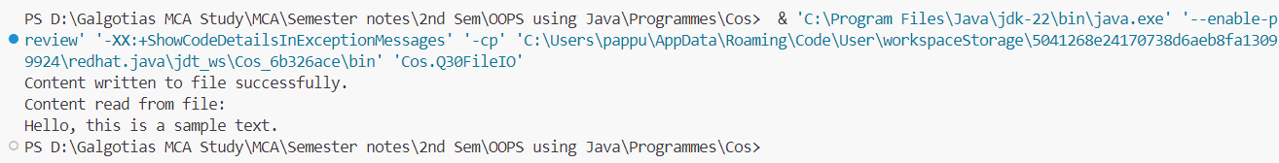

**Program 31**

**Objective: WAP in java to reading and writing in file using character stream.**

package Cos;

import java.io.FileReader;

import java.io.FileWriter;

import java.io.IOException;

public class Q31FileWrite {

    public static void main(String[] args) {

        String fileName = "example.txt";

        String content = "Hello, this is a sample text.";

        // Writing to a file using FileWriter

        try (FileWriter writer = new FileWriter(fileName)) {

            writer.write(content);

            System.out.println("Content written to file successfully.");

        } catch (IOException e) {

            System.out.println("Error writing to file: " + e.getMessage());

        }

        // Reading from a file using FileReader

        try (FileReader reader = new FileReader(fileName)) {

            int ch;

            System.out.println("Content read from file:");

            while ((ch = reader.read()) != -1) {

                System.out.print((char) ch);

            }

        } catch (IOException e) {

            System.out.println("Error reading from file: " + e.getMessage());

        }

    }

}

**Output**

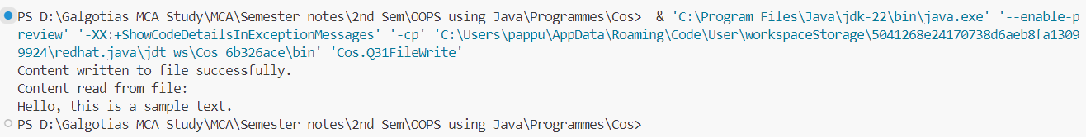

**Program 32**

**Objective: WAP in java to reading and writing through console class.**

package Cos;

import java.util.Scanner;

public class Q32ConsoleIO {

    public static void main(String[] args) {

        Scanner scanner = new Scanner(System.in);

        // Reading input from the console

        System.out.print("Enter your name: ");

        String name = scanner.nextLine();

        // Writing output to the console

        System.out.println("Hello, " + name + "! Welcome to the console I/O example.");

        // Closing the scanner

        scanner.close();

    }

}

**Output**

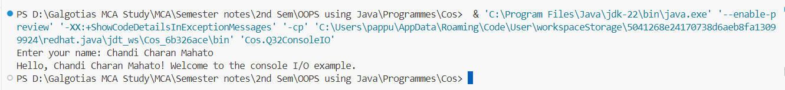

**Program 33**

**Objective: WAP in java how to create thread using Thread Class.**

package Cos;

public class Q33Thread extends Thread {

    public void run() {

        // Code to be executed by the thread

        for (int i = 0; i < 5; i++) {

            System.out.println("Thread running: " + i);

            try {

                // Sleep for 1 second

                Thread.sleep(1000);

            } catch (InterruptedException e) {

                e.printStackTrace();

            }

        }

    }

    public static void main(String[] args) {

        // Create an instance of Q33

        Q33Thread thread = new Q33Thread();

        // Start the thread

        thread.start();

    }

}

**Output**

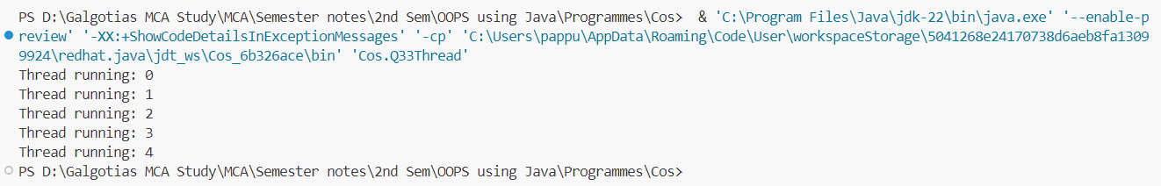

**Program 34**

**Objective: WAP in java how to create thread using runnable interface.**

package Cos;

public class Q34ThreadInstance implements Runnable {

    public void run() {

        // Code to be executed by the thread

        for (int i = 0; i < 5; i++) {

            System.out.println("Thread running: " + i);

            try {

                // Sleep for 1 second

                Thread.sleep(1000);

            } catch (InterruptedException e) {

                e.printStackTrace();

            }

        }

    }

    public static void main(String[] args) {

        // Create an instance of Q34

        Q34ThreadInstance myRunnable = new Q34ThreadInstance();

        // Create a Thread object with myRunnable as the target

        Thread thread = new Thread(myRunnable);

        // Start the thread

        thread.start();

    }

}

**Output**

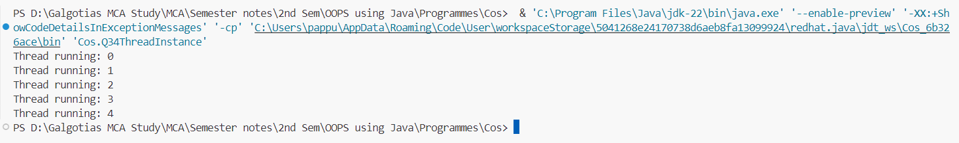

**Program 35**

**Objective: WAP in java to implement multithreading.**

package Cos;

// Runnable implementation

class MyRunnable implements Runnable {

    public void run() {

        for (int i = 1; i <= 5; i++) {

            System.out.println("Thread " + Thread.currentThread().getId() + ": " + i);

            try {

                Thread.sleep(1000); // Sleep for 1 second

            } catch (InterruptedException e) {

                e.printStackTrace();

            }

        }

    }

}

public class Q35ThreadsWInterface {

    public static void main(String[] args) {

        // Creating and starting threads using Runnable interface

        Thread thread1 = new Thread(new MyRunnable());

        Thread thread2 = new Thread(new MyRunnable());

        thread1.start();

        thread2.start();

        // Creating and starting threads using Thread class

        MyThread myThread1 = new MyThread();

        MyThread myThread2 = new MyThread();

        myThread1.start();

        myThread2.start();

    }

}

// Thread class extension

class MyThread extends Thread {

    public void run() {

        for (int i = 1; i <= 5; i++) {

            System.out.println("Thread " + Thread.currentThread().getId() + ": " + i);

            try {

                Thread.sleep(1000); // Sleep for 1 second

            } catch (InterruptedException e) {

                e.printStackTrace();

            }

        }

    }

}

**Output**

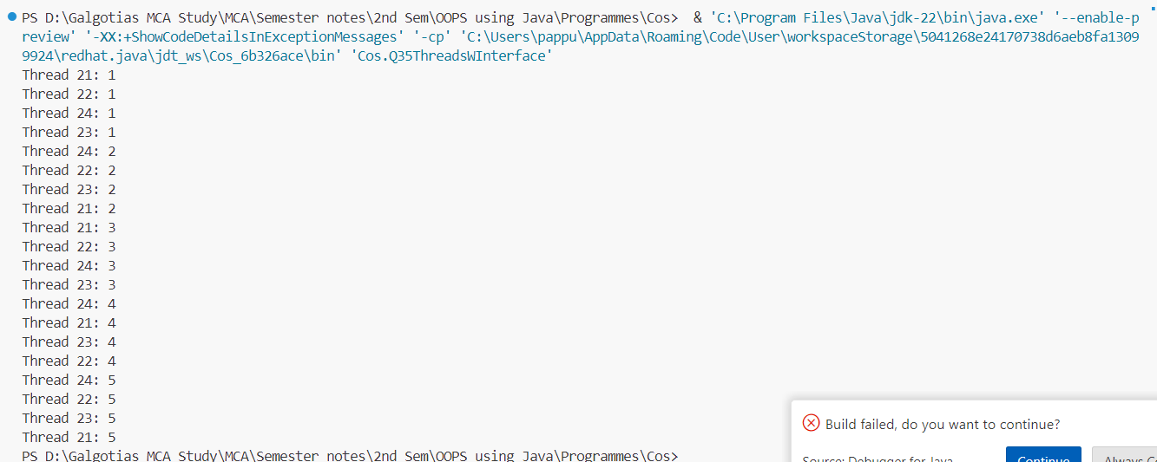

**Program 36**

**Objective: WAP in java to achieve synchronization in threads.**

package Cos;

class Counter {

    private int count = 0;

    // Synchronized method to increment the count

    public synchronized void increment() {

        count++;

    }

    // Method to get the current count

    public int getCount() {

        return count;

    }

}

class MyThread extends Thread {

    private Counter counter;

    public MyThread(Counter counter) {

        this.counter = counter;

    }

  public void run() {

        for (int i = 0; i < 1000; i++) {

            counter.increment();

        }

    }

}

public class Q36synchronizedFunction{

    public static void main(String[] args) {

        Counter counter = new Counter();

        MyThread thread1 = new MyThread(counter);

        MyThread thread2 = new MyThread(counter);

        thread1.start();

        thread2.start();

        try {

            thread1.join();

            thread2.join();

        } catch (InterruptedException e) {

            e.printStackTrace();

        }

// The expected value of count should be 2000

        System.out.println("Final count: " + counter.getCount());

    }

}

**Output**

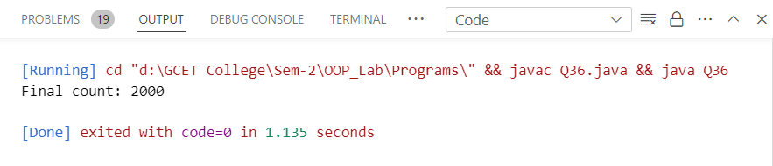

**Program 37**

**Objective: WAP in java to implement the concept of Priorities of threads.**

package Cos;

class MyThread extends Thread {

    public MyThread(String name) {

        super(name);

    }

    public void run() {

        System.out.println("Thread: " + getName() + " Priority: " + getPriority());

    }

}

public class Q37DifferThread {

    public static void main(String[] args) {

        // Create three threads with different priorities

        MyThread thread1 = new MyThread("Thread 1");

        MyThread thread2 = new MyThread("Thread 2");

        MyThread thread3 = new MyThread("Thread 3");

        // Set priorities for threads

        thread1.setPriority(Thread.MIN_PRIORITY);

        thread2.setPriority(Thread.NORM_PRIORITY);

        thread3.setPriority(Thread.MAX_PRIORITY);

        // Start the threads

        thread1.start();

        thread2.start();

        thread3.start();

    }

}

**Output**

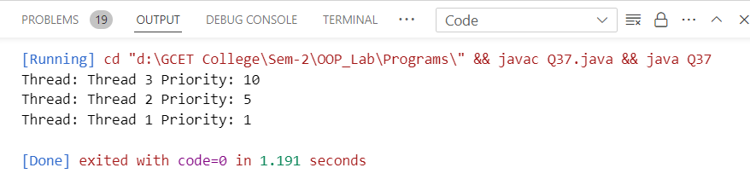

**Program 38**

**Objective: WAP in java to illustrate the concept of Generic Programming.**

// A generic class representing a generic box that can hold any type of object

class Box<T> {

    private T item;

    public void setItem(T item) {

        this.item = item;

    }

    public T getItem() {

        return item;

    }

    public void displayItemType() {

        System.out.println("Type of item in the box: " + item.getClass().getName());

    }

}

public class Q38 {

    public static void main(String[] args) {

        // Create a Box to hold an integer

        Box<Integer> intBox = new Box<>();

        intBox.setItem(123);

        System.out.println("Item in the integer box: " + intBox.getItem());

        intBox.displayItemType();

        // Create a Box to hold a string

        Box<String> stringBox = new Box<>();

        stringBox.setItem("Hello, Generics!");

        System.out.println("Item in the string box: " + stringBox.getItem());

        stringBox.displayItemType();

    }

}

**Output**

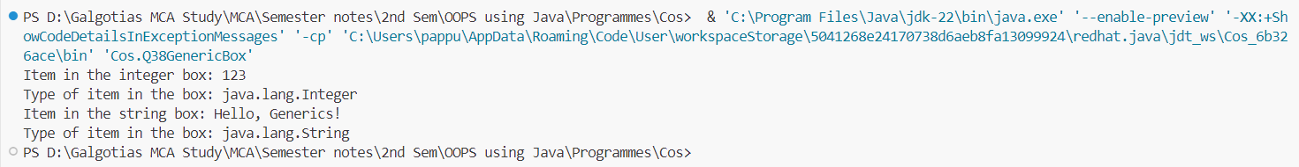

**Program 39**

**Objective: WAP in java to illustrate the concept of event handling (using various event handlers).**

import java.awt.*;

import java.awt.event.*;

public class Q39 extends Frame implements ActionListener, MouseListener, KeyListener {

    private TextField textField;

    private Label label;

    public Q39() {

        // Create components

        label = new Label("Click inside the window and press any key:");

        textField = new TextField(20);

        // Add components to the frame

        add(label, BorderLayout.NORTH);

        add(textField, BorderLayout.SOUTH);

        // Add event listeners

        addMouseListener(this);

        addKeyListener(this);

        // Set frame properties

        setTitle("Event Handling Example");

        setSize(300, 200);

        setVisible(true);

    }

    // ActionListener event handler

    public void actionPerformed(ActionEvent e) {

        textField.setText("Button clicked!");

    }

    // MouseListener event handlers

    public void mouseClicked(MouseEvent e) {

        textField.setText("Mouse clicked at (" + e.getX() + ", " + e.getY() + ")");

    }

    public void mouseEntered(MouseEvent e) {}

    public void mouseExited(MouseEvent e) {}

    public void mousePressed(MouseEvent e) {}

    public void mouseReleased(MouseEvent e) {}

    // KeyListener event handlers

    public void keyPressed(KeyEvent e) {

        textField.setText("Key pressed: " + e.getKeyChar());

    }

    public void keyReleased(KeyEvent e) {}

    public void keyTyped(KeyEvent e) {}

    public static void main(String[] args) {

        new Q39();

    }

}

**Output**

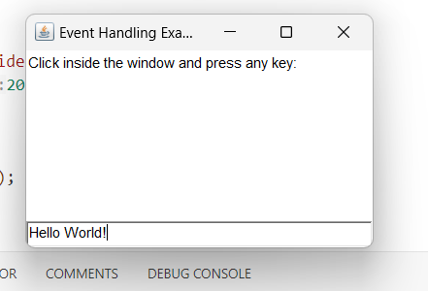

**Program 40**

**Objective: Create a simple registration application using various swing components (like: JFrame, JButton, JLabel, text fields, text areas, check box and ratio buttons).**

package Cos;

import javax.swing.*;

import java.awt.*;

import java.awt.event.*;

public class RegistrationApp extends JFrame implements ActionListener {

    private JTextField firstNameField, lastNameField;

    private JRadioButton maleRadioButton, femaleRadioButton;

    private JTextArea addressArea;

    private JCheckBox termsCheckBox;

    private JButton registerButton;

    public RegistrationApp() {

        // Set frame properties

        setTitle("Registration Application");

        setSize(400, 300);

        setDefaultCloseOperation(JFrame.EXIT_ON_CLOSE);

        setLayout(new BorderLayout());

        // Create components

        JPanel formPanel = new JPanel(new GridLayout(6, 2));

        JLabel firstNameLabel = new JLabel("First Name:");

        firstNameField = new JTextField();

        JLabel lastNameLabel = new JLabel("Last Name:");

        lastNameField = new JTextField();

        JLabel genderLabel = new JLabel("Gender:");

        maleRadioButton = new JRadioButton("Male");

        femaleRadioButton = new JRadioButton("Female");

        ButtonGroup genderGroup = new ButtonGroup();

        genderGroup.add(maleRadioButton);

        genderGroup.add(femaleRadioButton);

        JLabel addressLabel = new JLabel("Address:");

        addressArea = new JTextArea(4, 20);

        JScrollPane scrollPane = new JScrollPane(addressArea);

        JLabel termsLabel = new JLabel("Accept Terms and Conditions:");

        termsCheckBox = new JCheckBox();

        registerButton = new JButton("Register");

        // Add components to the form panel

        formPanel.add(firstNameLabel);

        formPanel.add(firstNameField);

        formPanel.add(lastNameLabel);

        formPanel.add(lastNameField);

        formPanel.add(genderLabel);

        formPanel.add(maleRadioButton);

        formPanel.add(new JLabel()); // Empty space

        formPanel.add(femaleRadioButton);

        formPanel.add(addressLabel);

        formPanel.add(scrollPane);

        formPanel.add(termsLabel);

        formPanel.add(termsCheckBox);

        // Add register button action listener

        registerButton.addActionListener(this);

        // Add components to the frame

        add(formPanel, BorderLayout.CENTER);

        add(registerButton, BorderLayout.SOUTH);

        // Set frame visible

        setVisible(true);

    }

    public void actionPerformed(ActionEvent e) {

        if (e.getSource() == registerButton) {

            // Perform registration process

            String firstName = firstNameField.getText();

            String lastName = lastNameField.getText();

            String gender = maleRadioButton.isSelected() ? "Male" : "Female";

            String address = addressArea.getText();

            boolean acceptedTerms = termsCheckBox.isSelected();

            // Display registration information

            String message = "Registration Successful!\n\n";

            message += "First Name: " + firstName + "\n";

            message += "Last Name: " + lastName + "\n";

            message += "Gender: " + gender + "\n";

            message += "Address: " + address + "\n";

            message += "Terms and Conditions Accepted: " + (acceptedTerms ? "Yes" : "No");

            JOptionPane.showMessageDialog(this, message, "Registration Info", JOptionPane.INFORMATION_MESSAGE);

        }

    }

    public static void main(String[] args) {

        new RegistrationApp();

    }

}

**Output**

